weel 7 React
Create a React Application named “cricketapp” with the following components:
import React from 'react';

const IndianPlayers = () => {
const T20 = ["Kohli", "Rohit", "Pant", "Surya"];
const Ranji = ["Jaiswal", "Sarfaraz", "Pujara", "Shaw"];

const merged = [...T20, ...Ranji];
const [p1, p2, p3, p4] = merged;

return (
<div>
<h2>Merged Players</h2>
<ul>
{merged.map((player, index) => (
<li key={index}>{player}</li>
))}
</ul>

<h3>Destructured Players</h3>
<p>Odd Team: {p1}, {p3}</p>
<p>Even Team: {p2}, {p4}</p>
</div>
);
};

export default IndianPlayers;
import React from 'react';

const ListofPlayers = () => {
const players = [
{ name: "Virat", score: 85 },
{ name: "Rohit", score: 95 },
{ name: "Dhoni", score: 65 },
{ name: "Rahul", score: 75 },
{ name: "Pant", score: 55 },
{ name: "Hardik", score: 60 },
{ name: "Jadeja", score: 88 },
{ name: "Shami", score: 40 },
{ name: "Bumrah", score: 90 },
{ name: "Ashwin", score: 78 },
{ name: "Gill", score: 70 }
];

const below70 = players.filter(player => player.score < 70);

return (
<div>
<h2>All Players</h2>
<ul>
{players.map((p, i) => (
<li key={i}>{p.name} - {p.score}</li>
))}
</ul>

<h3>Players Scoring Below 70</h3>
<ul>
{below70.map((p, i) => (
<li key={i}>{p.name}</li>
))}
</ul>
</div>
);
};

export default ListofPlayers;
import React from 'react';
import ListofPlayers from './components/ListofPlayers';
import IndianPlayers from './components/IndianPlayers';

function App() {
const flag = true;

return (
<div className="App">
<h1>🏏 Welcome to Cricket App</h1>
{flag ? <ListofPlayers /> : <IndianPlayers />}
</div>
);
}

export default App;
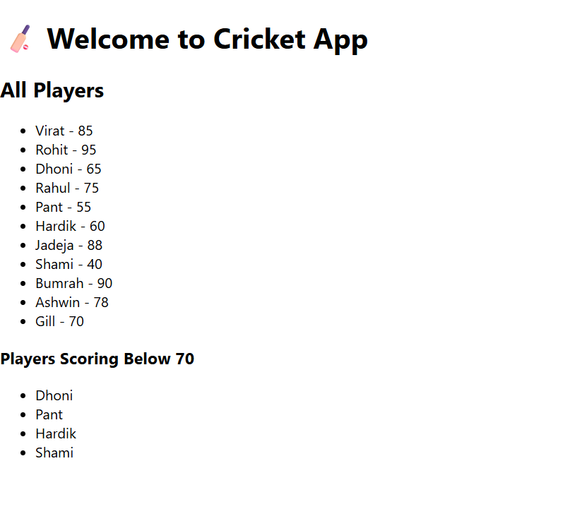

Create a React Application named “officespacerentalapp” which uses React JSX to create elements, attributes and renders DOM to display the page.

import React from 'react';

const OfficeList = () => {
const offices = [
{
name: "Tech Park Office",
rent: 55000,
address: "MG Road, Bangalore",
image: "https://via.placeholder.com/200x100?text=Tech+Park"
},
{
name: "Startup Hub",
rent: 75000,
address: "Gachibowli, Hyderabad",
image: "https://via.placeholder.com/200x100?text=Startup+Hub"
},
{
name: "EcoSpace",
rent: 62000,
address: "Whitefield, Bangalore",
image: "https://via.placeholder.com/200x100?text=EcoSpace"
}
];

const heading = <h1 style={{ color: "#444", textAlign: "center" }}>🏢 Office Space Rental App</h1>;

return (
<div>
{heading}
{offices.map((office, index) => (
<div key={index} style={{ border: "1px solid gray", margin: "10px", padding: "10px" }}>
<img src={office.image} alt={office.name} style={{ width: "200px", height: "100px" }} />
<h2>{office.name}</h2>
<p><strong>Address:</strong> {office.address}</p>
<p style={{ color: office.rent < 60000 ? "red" : "green" }}>
<strong>Rent:</strong> ₹{office.rent}
</p>
</div>
))}
</div>
);
};

export default OfficeList;
import React from 'react';
import OfficeList from './OfficeList';

function App() {
return (
<div className="App">
<OfficeList />
</div>
);
}

export default App;
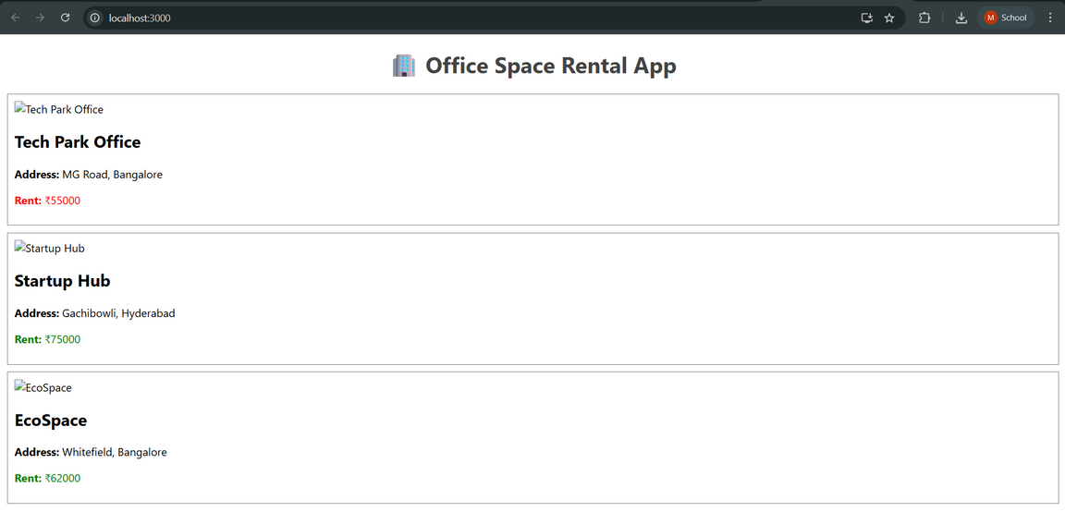
Create a React Application “eventexamplesapp” to handle various events of the form elements in HTML.
import React, { Component } from 'react';

class CounterEvents extends Component {
constructor(props) {
super(props);
this.state = {
count: 0
};
}

increment = () => {
this.setState({ count: this.state.count + 1 });
this.sayHello();
};

decrement = () => {
this.setState({ count: this.state.count - 1 });
};

sayHello = () => {
alert("Hello! You clicked Increase!");
};

sayWelcome = (msg) => {
alert(msg);
};

handleSyntheticEvent = (e) => {
alert("I was clicked");
};

render() {
return (
<div style={{ marginBottom: '30px' }}>
<h2>Counter Example</h2>
<p>Value: {this.state.count}</p>
<button onClick={this.increment}>Increase</button>
<button onClick={this.decrement}>Decrease</button>
<br /><br />
<button onClick={() => this.sayWelcome("Welcome to React Events!")}>Say Welcome</button>
<br /><br />
<button onClick={this.handleSyntheticEvent}>Synthetic Event Button</button>
</div>
);
}
}

export default CounterEvents;
import React, { useState } from 'react';

const CurrencyConvertor = () => {
const [rupees, setRupees] = useState('');
const [euro, setEuro] = useState('');

const handleConvert = () => {
if (!rupees || isNaN(rupees)) {
alert("Please enter a valid number.");
return;
}
const converted = (parseFloat(rupees) / 90).toFixed(2);
setEuro(converted);
};

return (
<div>
<h2>Currency Convertor</h2>
<input
type="text"
placeholder="Enter INR"
value={rupees}
onChange={(e) => setRupees(e.target.value)}
/>
<button onClick={handleConvert}>Convert</button>
{euro && (
<p>Converted Amount: €{euro}</p>
)}
</div>
);
};

export default CurrencyConvertor;
import React from 'react';
import CounterEvents from './CounterEvents';
import CurrencyConvertor from './CurrencyConvertor';

function App() {
return (
<div className="App">
<h1>🎯 React Event Examples</h1>
<CounterEvents />
<hr />
<CurrencyConvertor />
</div>
);
}

export default App;
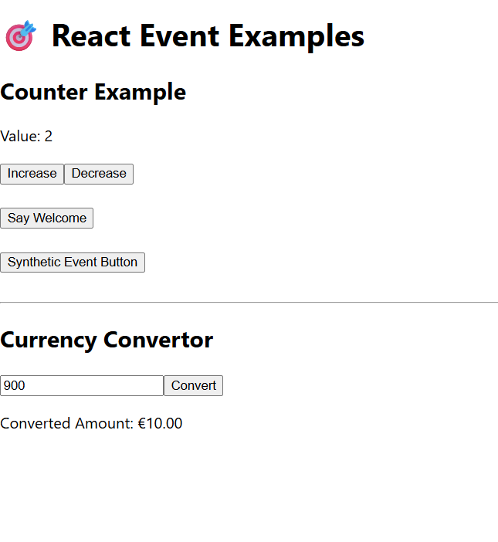
Create a React Application named “ticketbookingapp” where the guest user can browse the page where the flight details are displayed whereas the logged in user only can book tickets.
import React from 'react';

const GuestPage = () => {
return (
<div>
<h2>Welcome, Guest 👋</h2>
<p>Here are today's available flights:</p>
<ul>
<li>✈️ Hyderabad → Delhi - 9:00 AM</li>
<li>✈️ Bangalore → Mumbai - 1:30 PM</li>
<li>✈️ Chennai → Kolkata - 6:45 PM</li>
</ul>
<p><strong>Login</strong> to book your ticket!</p>
</div>
);
};

export default GuestPage;
import React, { useState } from 'react';
import GuestPage from './GuestPage';
import UserPage from './UserPage';

const LoginControl = () => {
const [isLoggedIn, setIsLoggedIn] = useState(false);

const handleLogin = () => setIsLoggedIn(true);
const handleLogout = () => setIsLoggedIn(false);

let content;
if (isLoggedIn) {
content = <UserPage />;
} else {
content = <GuestPage />;
}

return (
<div>
<h1>✈️ Ticket Booking App</h1>
{isLoggedIn ? (
<button onClick={handleLogout}>Logout</button>
) : (
<button onClick={handleLogin}>Login</button>
)}
<hr />
{content}
</div>
);
};

export default LoginControl;
import React from 'react';

const UserPage = () => {
return (
<div>
<h2>Welcome, User ✅</h2>
<p>You can now book your tickets.</p>
<button>Book Flight</button>
</div>
);
};

export default UserPage;
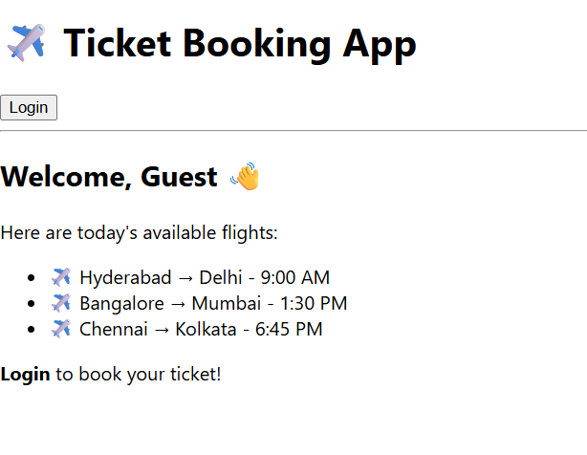
Create a React App named “bloggerapp” in with 3 components.

1. Book Details
2. Blog Details
3. Course Details

Implement this with as many ways possible of Conditional Rendering.
import React from 'react';

const BlogDetails = () => {
return (
<div>
<h2>📝 Blog Details</h2>
<p>This section shows information about a blog post.</p>
</div>
);
};

export default BlogDetails;
import React from 'react';

const BookDetails = () => {
return (
<div>
<h2>📘 Book Details</h2>
<p>This section shows information about a book.</p>
</div>
);
};

export default BookDetails;
import React from 'react';

const CourseDetails = () => {
return (
<div>
<h2>🎓 Course Details</h2>
<p>This section shows information about a course.</p>
</div>
);
};

export default CourseDetails;
import { useState } from 'react';
import BookDetails from './components/BookDetails';
import BlogDetails from './components/BlogDetails';
import CourseDetails from './components/CourseDetails';

function App() {
const [view, setView] = useState("book");

return (
<div>
<button onClick={() => setView("book")}>Show Book</button>
<button onClick={() => setView("blog")}>Show Blog</button>
<button onClick={() => setView("course")}>Show Course</button>

{/* Conditional rendering using ternary */}
{view === "book" ? <BookDetails /> : null}
{view === "blog" && <BlogDetails />}
{view === "course" ? <CourseDetails /> : null}
</div>
);
}

export default App;
